**Merge Excel Files**

1. Please first ensure that you have installed Python correctly as per my “Install Python” instructions. Then run the command prompt from your start menu.

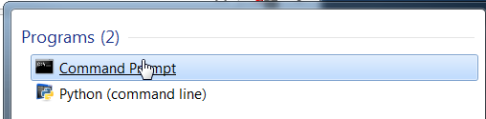

1. Type “pip install pandas” and wait for installation to complete. If you are having trouble installing pandas, please ensure that you have installed Python correctly as per my “Install Python” instructions.

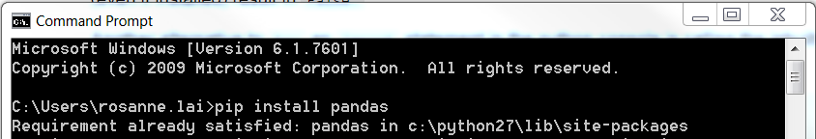

Then type “pip install glob2”.



You have now downloaded the packages you will need to run the Merge Excel Files Python script.

1. Go to: <https://github.com/rosannelai/Merge_Excel_Files/blob/master/Merge_Excel_Files.py>

Open raw

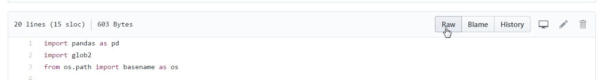

1. Save to your computer as a Python file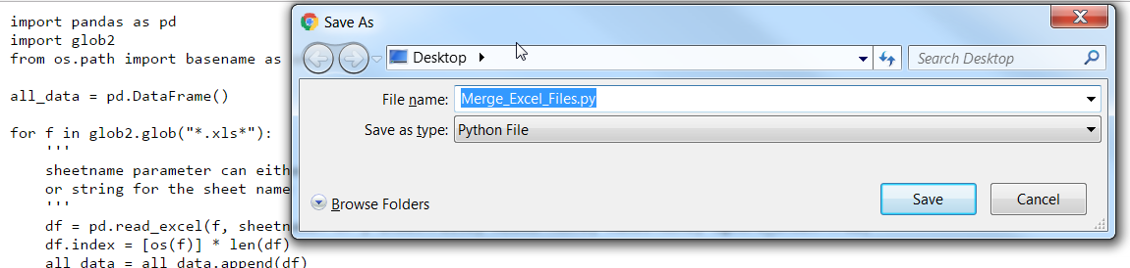
2. Copy and paste the Python file into the folder containing the files you wish to merge

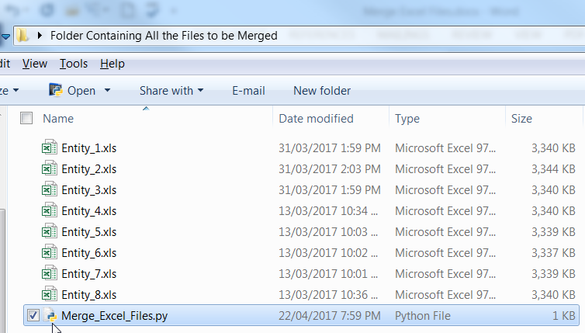

1. Right-click on the Python file and select “Edit with Idle”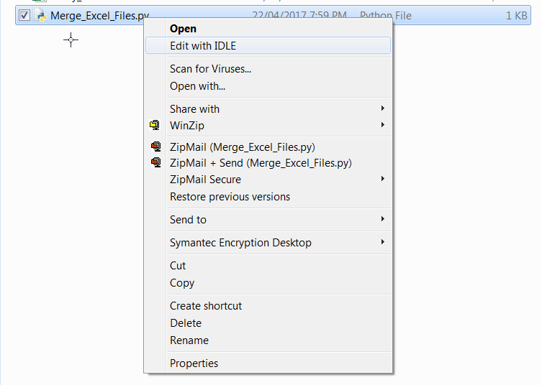
2. Change the sheetname parameter as indicated to either the name of the sheet in the files that you wish to merge, or to an integer for the index of the sheet in the files.

This is the most frequent use for me when I am merging files. If you wish to merge ALL sheets within each file, please download the script that I have modified for this functionality at: <https://github.com/rosannelai/Merge_Excel_Files/blob/master/Merge_Excel_Files_ALLSHEETS.py>

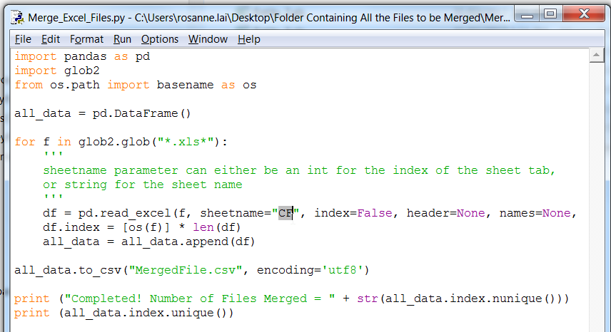

1. Press “F5” to run module. The code will show you the list of file names which you have merged, and the count of files which you have merged to check for completeness.

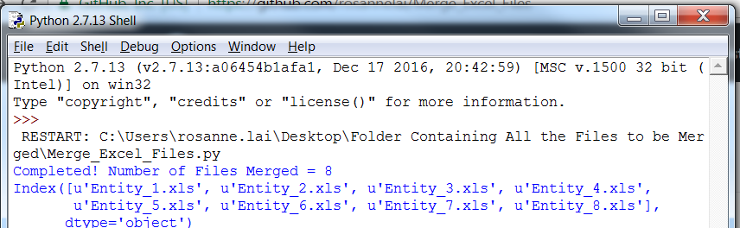

1. Right-click on the MergedFile.csv and select “Open With” > “Excel”.

